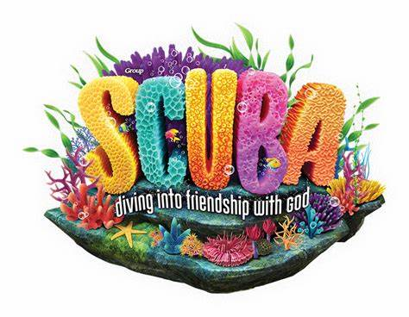
VACATION BIBLE SCHOOL
Child Participant: Registration Form
(PLEASE COMPLETE BOTH SIDES)
Dates / Location: June 10 - 14, 9:00 AM - 11:00 AM, Holy Name of Mary
Please return completed form by _____May 12, 2024_______________
==================================================================================
Name of each child participant: | Age and grade for 2024- 25 School Year  Children ages 4 - rising 5th grade

PLEASE COMPLETE BOTH SIDES OF FORM

Family Information:

Parents/Guardians’ Name(s): _______________________________________________________

Address: _______________________________________________________________________

Phone: Hm: __________________ Wk: ___________________ Cell: ____________________

Email: _________________________________________________________________________

Emergency Contact:

Name: _________________________________________________________________________
Doctor's Name and Phone__________________________________________________________
Insurance Company_______________________________________________________________
Health Insurance ID #___________________________________________
Phone: __________________________________ Email: _______________________________

I understand that reasonable precautions will be taken to safeguard the health and well-being of the participants in this VBS at Holy Name of Mary and that I will be notified as soon as possible in the event of an emergency. In the case of sickness or an accident, I authorize and consent the VBS Team, or other associated volunteers of the VBS program to obtain medical care from a licensed physician, hospital, or medical clinic for my son/daughter in the event that myself or other legal guardian(s) cannot be reached. I hereby release and forever discharge this Diocese (Richmond Diocese), and Parish (Holy Name of Mary) from all manners of actions, claims which I or the child named above shall or may have for any reason, arising during my child’s attendance of the VBS.

_____________________________________________________ ______________________________
Parent / Guardian Signature Date

PHOTO RELEASE- I give permission for photographs of the persons on this registration to be published on the website/Facebook page of Holy Name of Mary Catholic Church. I understand that these photos can be viewed by anyone, but no Identifying Information will be displayed.

I am the parent or legal guardian of the following child(ren) under 18 years of age, and I give permission for their Images to be published.

_____________________________________________________ ________________________________

Parent / Guardian Signature Date

VACATION BIBLE SCHOOL:
YOUTH/TEEN Volunteer Form
(PLEASE COMPLETE BOTH SIDES)
Dates / Location: June 10 - 14, 9:00 AM - 11:00 AM, Holy Name of Mary
Please return completed form by _____May 12, 2024_______________
==================================================================================
Name of each youth/teen volunteer | Age and grade for 2024- 25 School Year:  Rising 6th grade-rising 12th graders may be youth/teen volunteers

PLEASE COMPLETE BOTH SIDES OF FORM

Family Information:

Parents/Guardians’ Name(s): _______________________________________________________

Address: _______________________________________________________________________

Phone: Hm: __________________ Wk: ___________________ Cell: ____________________

Email: _________________________________________________________________________

Emergency Contact:

Name: _________________________________________________________________________
Doctor's Name and Phone__________________________________________________________
Insurance Company_______________________________________________________________
Health Insurance ID #___________________________________________
Phone: __________________________________ Email: _______________________________

I understand that reasonable precautions will be taken to safeguard the health and well-being of the participants in this VBS at Holy Name of Mary and that I will be notified as soon as possible in the event of an emergency. In the case of sickness or an accident, I authorize and consent the VBS Team, or other associated volunteers of the VBS program to obtain medical care from a licensed physician, hospital, or medical clinic for my son/daughter in the event that myself or other legal guardian(s) cannot be reached. I hereby release and forever discharge this Diocese (Richmond Diocese), and Parish (Holy Name of Mary) from all manners of actions, claims which I or the child named above shall or may have for any reason, arising during my child’s attendance of the VBS.

_____________________________________________________ ______________________________
Parent / Guardian Signature Date

PHOTO RELEASE- I give permission for photographs of the persons on this registration to be published on the website/Facebook page of Holy Name of Mary Catholic Church. I understand that these photos can be viewed by anyone, but no Identifying Information will be displayed.

I am the parent or legal guardian of the following child(ren) under 18 years of age, and I give permission for their Images to be published.

_____________________________________________________ ________________________________

Parent / Guardian Signature Date

